Name: Nafinur Leo

Id: 20-42195-1

Section: H

1.Discussion about properties through oscilloscope:

Peak voltage: The maximum vertical deviation of the trace from the center line is measured from the screen. This number of divisions is multiplied by the Y gain from the oscilloscope controls. In this way we can find peak voltage through oscilloscope.

Peak to peak voltage: Adjusting vertical position and sensitivity for the largest display of the vertical height of the signal, so that both the uppermost and lowermost parts of the signal are on screen at the same time. Use only the fixed vertical sensitivity settings on the scope. Measuring the vertical distance in cm between the uppermost signal level and the lowermost level. Multiplying the measurement from step two by the vertical sensitivity setting of the ‘scope, and you will have the p-p voltage. In this way we can find peak to peak voltage through oscilloscope.

Rms value: here for the rms measurement, oscilloscopes use the waveform samples in the acquisition memory for calculation. It is a standard measurement feature that is present in almost any digital oscilloscope.

Average value: The numerical approach for the average consists of summing all the values of a signal and divide the sum by the number of values.

Crest factor: One key parameter derived from the two values mentioned above is crest factor, which is the ratio of the peak value to the root-mean-square (rms) value of a waveform. This is expressed by the equation C = XPEAK ÷ XRMS. In this way we can find crest factor through oscilloscope.

Quality factor: Quality factor is the ratio of reactance and resistance. We can calculate effective resistance R and effective reactance X of RLC circuit for a given frequency. Then Q = X/R. In this way we can find quality factor through oscilloscope.

Time period: Counting the number of horizontal divisions from one high point to the next of my oscillating signal. Next, I'll multiply the number of horizontal divisions by the time/division to find the signal's period. In this way we can find time period through oscilloscope.

Frequency: Oscilloscope bandwidth is defined as the frequency at which the amplitude of the observed signal drops by -3 dB as we increase the test signal's frequency as plotted on the amplitude-frequency characteristic curve. In this way we can find frequency through oscilloscope.

Amplitude: I'll measure the signal's amplitude by counting the number of vertical divisions between the signal's highest and lowest points. Then I can get the amplitude in volts by multiplying the number of vertical divisions by your volts/division setting. In this way we can find amplitude through oscilloscope.

Cycle: This measurement is available for measurement of single-valued waveforms in oscilloscope mode only. The time between the edges of the waveform used for the duty cycle measurement is taken at the middle threshold crossings. In this way we can find cycle through oscilloscope.

Angular frequency: The angular frequency ω is given by ω = 2π/T. The angular frequency is measured in radians per second. The inverse of the period is the frequency f = 1/T. The frequency f = 1/T = ω/2π of the motion gives the number of complete oscillations per unit time. In this way we can find angular frequency through oscilloscope.

2.Solving RLC network:

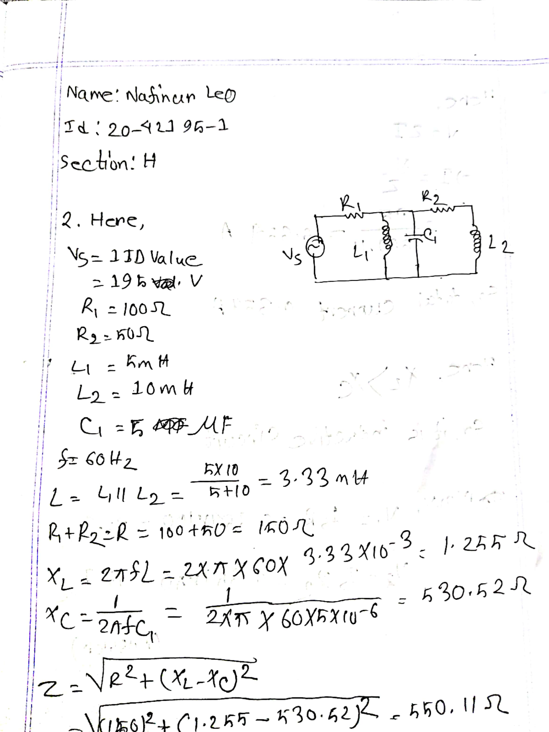

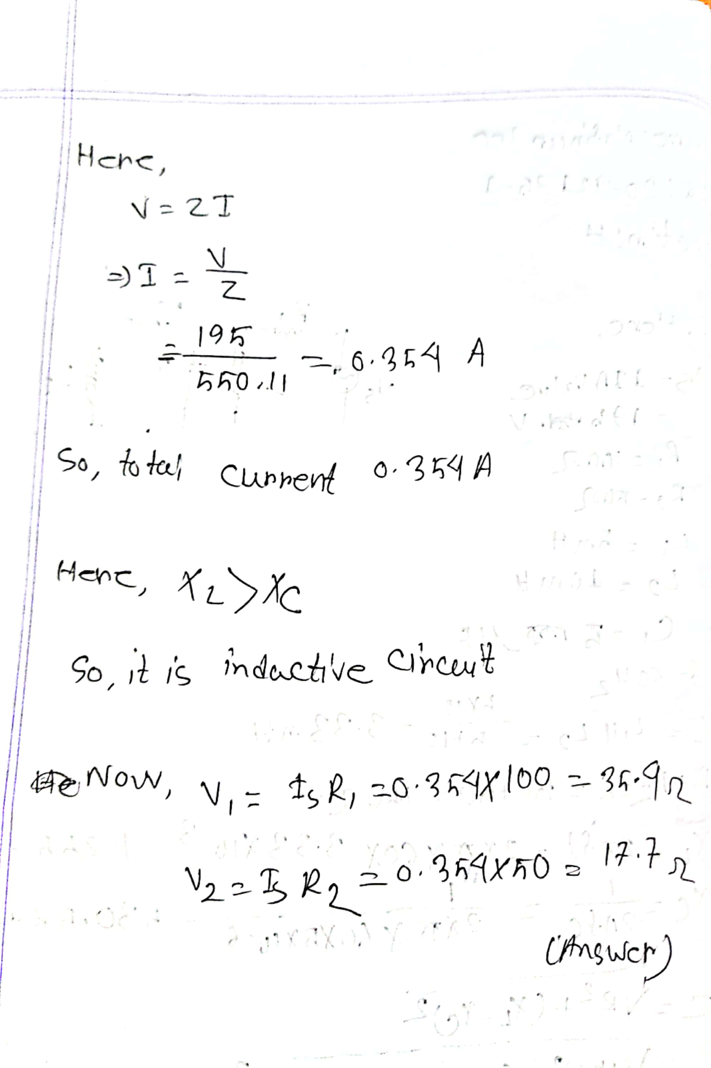

Simulations:

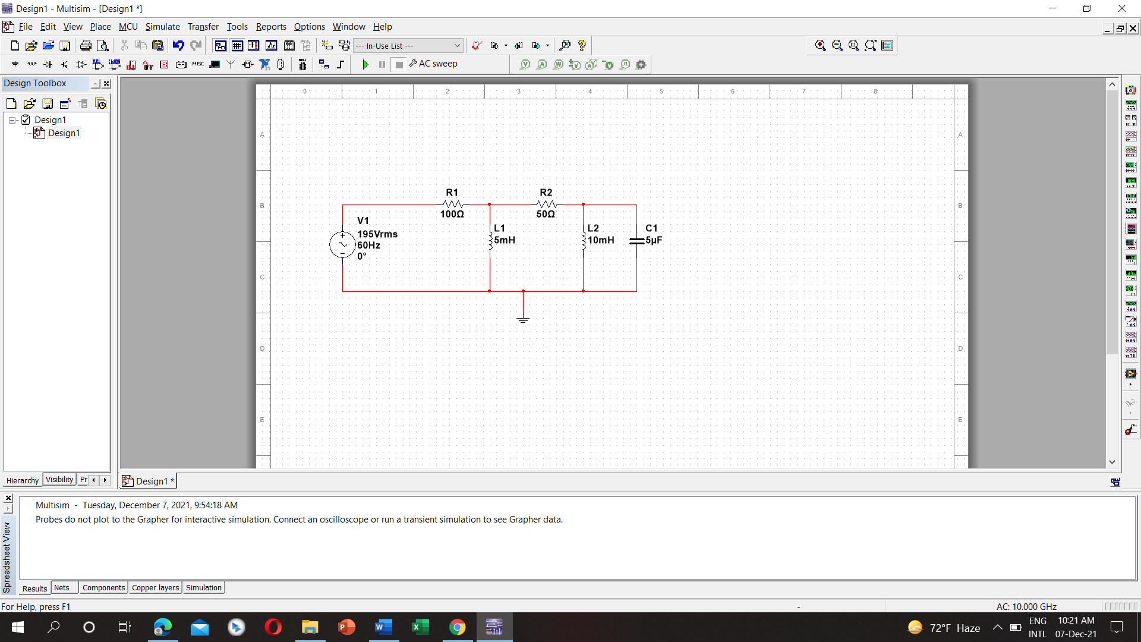

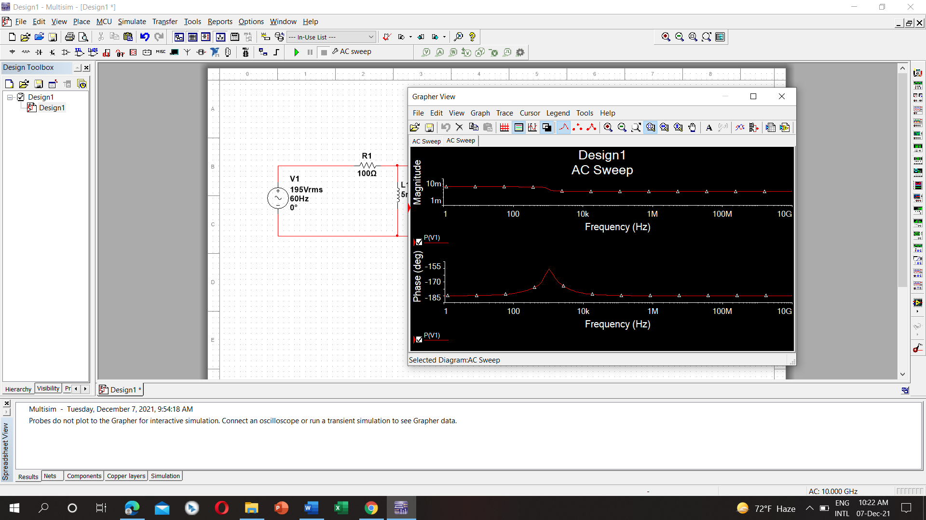

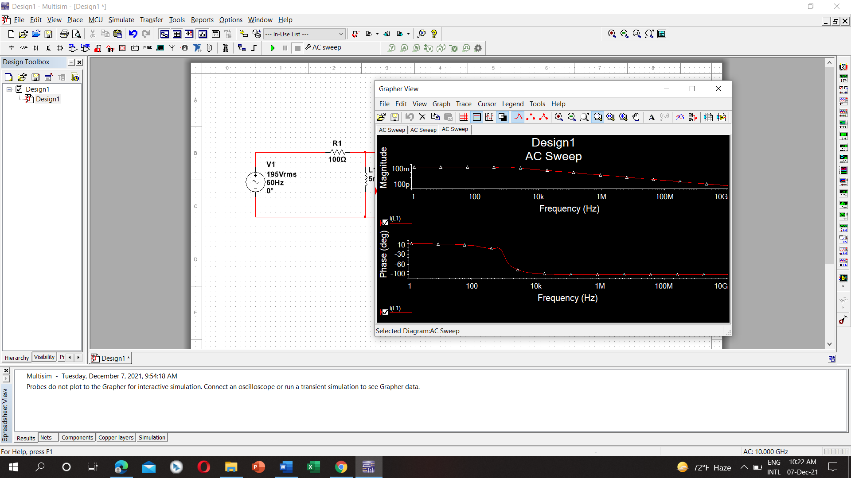

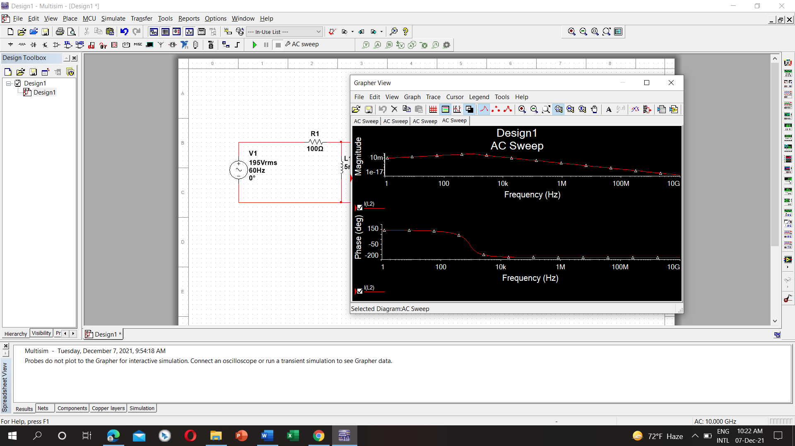

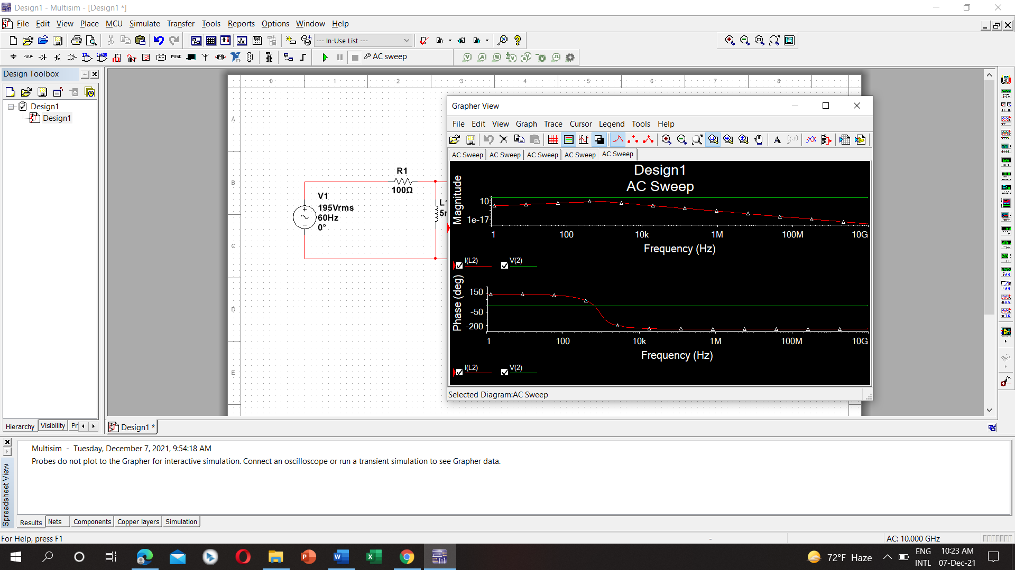

3.Importance of resonance in communication circuit:

Resonance occurs whenever the phase angle of the circuit is zero. Generally, resonance is achieved by varying the angular frequency w the circuit until XL = X C. The importance of resonance is that the circuit can either absorb or dissipate the maximum amount of energy at resonance. The circuit then absorbs more energy from this impinging frequency than any of the other impinging frequencies. One practical example is used in a radio receiver. Many the frequencies from different radio stations are impinging on the radio's antenna at the same time. By varying the capacitance in a circuit, the circuit can be tuned so that the resonance frequency of the circuit is equal to the desired station frequency. The circuit then absorbs more energy from this impinging frequency than any of the other impinging frequencies. Resonant circuits exhibit ringing and can generate higher voltages or currents than are fed into them. They are widely used in wireless (radio) transmission for both transmission and reception.

4. Steps to select power factor correction device for a residential building:

Power Factor Correction (PFC) equipment is a technology which when installed allows the consumer to reduce their electricity bill by maintaining the level of reactive power consumption. If a site’s Power Factor falls below a predetermined figure, then the electricity company adds reactive power charges to your bill. In general, the strain on electrical infrastructure is reduced if Power Factor is good. Power Factor Correction Capacitors can be applied at individual motors, distribution panels, or on the main service panel. Fixed Capacitors can be connected at all three locations, or Automatic Capacitor Systems such as the Steelman VAR MANAGER can be installed on the main service panel. Fixed Capacitors are permanent values of KVAR connected to the electrical system, while Automatic Capacitor Systems vary the amount of KVAR that is connected based on sensing the entire electrical system requirements. If plant loads vary widely during any 24-hour period, large fixed capacitors at the main service panel are not recommended. Overcorrection may result, causing potential problems to the capacitors and adjacent connected equipment. In this case individual motor correction or an Automatic Capacitor System would be the best installation. As an example: To improve the power factor of a 400 KW load from .77 to .92:

161.2 KVAR would be required to correct the complete system. If individual motors are being corrected, the KVAR being connected to individual motors is subtracted from the overall KVAR required for the entire system. The balance would then be connected to the distribution system. If the total KVAR required was 161.2 as noted in the above example, and 100 KVAR had been connected to individual motors, the balance of 61.2 would be reduced to 60 KVAR and connected to the distribution system. In this way we can select power factor correction device for residential building.